**Ideation Phase**

**Empathize & Discover**

|  |  |
| --- | --- |
| Date | 28 June 2025 |
| Team ID | LTVIP2025TMID59203 |
| Project Name | EDUCATIONAL ORGANISATION USING SERVICENOW |
| Maximum Marks |  |

**Empathy Map Canvas:**

An empathy map is a simple, easy-to-digest visual that captures knowledge about a student’s, faculty member’s, or administrator’s behaviours and attitudes. It is a useful tool that helps education teams better understand their institutional users. Creating an effective solution requires understanding the core issues and the individual who is experiencing them. The exercise of creating the map helps participants consider situations from the user's perspective, along with their academic or administrative goals and challenges.

**Example:**

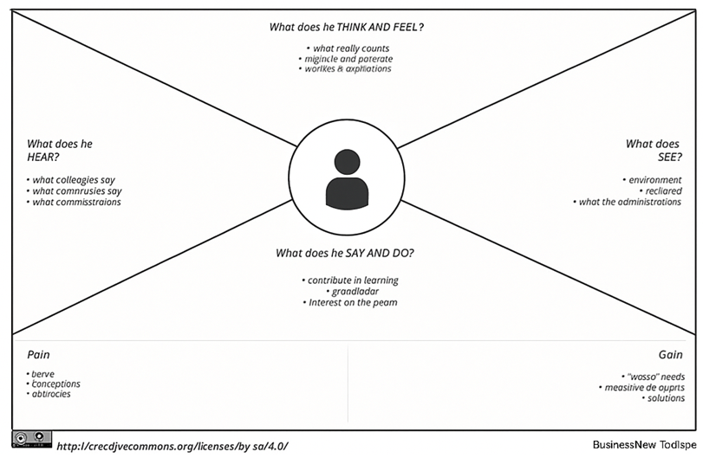

**Example: Educational Organisation Using ServiceNow**

